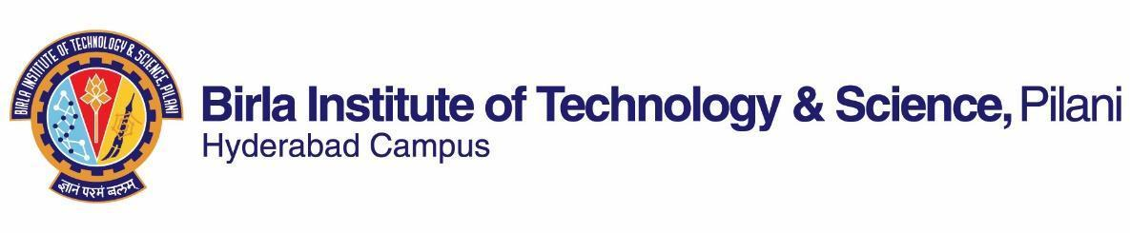

**SECOND SEMESTER 2020-2021**

# Course Handout Part II

Date: 16-01-2021

In addition to part-I (General Handout for all courses appended to the time table), this portion gives further specific details regarding the course.

*Course No.* : HSS F232

## Course Title : Introduction to Development Studies

## Instructor-in-Charge : Suchismita Satpathy

**Scope and Objective of the Course:** This inter-disciplinary course introduces students to the history, meanings and theories of development and examines how these theories have been applied to different countries and to different aspects of ‘development’ and in doing so, discusses and evaluates India’s development record in comparison to other developing countries. The objective is to familiarize students with the conceptual, theoretical and empirical tools to understand and appreciate the multi-faceted aspects of development, to question received wisdom, and perhaps contribute in small ways to building a more humane society.

**Textbooks:**

1. Desai, V., and Potter, R. B. (2014). Companion to Development Studies: Approaches, Actors and Issues (3rd edition). London: Routledge.
2. Haslam, P.A., Schaffer, J., and Beaudet, P. (2009). Introduction to International Development. New York: Oxford University Press.

**Reference books**

* + 1. Dreze, J., and Sen, A. (2013). An Uncertain Glory: India and Its Contradictions. New Delhi: Oxford University Press.
    2. Nagaraj, R. (2012). Growth, Inequality and Social Development in India: Is Inclusive Growth Possible? London: Palgrave.

**Course Plan:**

|  |  |  |  |
| --- | --- | --- | --- |
| **Lecture No.** | **Learning objectives** | **Topics to be covered** | **Chapter in the TextBook** |
| 1 | Understand the History of development, meanings of development | The context underlying the evolution of Development | TB1. Chs.1.2-1.3 |
| 2-10 | Discuss the Key development  Thinkers. | Smith, Marx, Liszt, Keynes, Prebisch, Friedman | RB |
| 11-20 | Analyse 20th century perspectives on development and assess the core aspects of non-conventional theories, their analytical differences, strategies for development | Dependency, modernization, human development, post- and anti-development  theories;  Marxism, socialism, dependency theories, post-development, alternatives to development | TB1. Chs. 2.6-2.14; TB2. Ch. 4 |
| 21-29 | Assess the conventional theories, their evolution, progress and consolidation as a strategy for economic development | Models of development: ISI and neoliberalism; Classical, neoclassical, Keynesianism and neoliberalism | TB1. Chs.1.5-1.7 and 1.12; TB2. Ch. 13TB1. Chs.2.2-2.5; TB2. Ch.3. |
| 30-37 | Identify and ascertain the nature of Themes in comparative international development, dimensions and varying impacts of some of the structural development issues | Environment, health,  gender, foreign aid, social and human rights. | TB1. 6.1, 6.7, 7.4-7.5; TB2. Ch. 17, 24 |
| 37-39 | Evaluate India’s development experience | Development performance of India, regional variations, development models | RB1. Chs. 5-8; RB2. Chs.2-4. |
| 40-42 | Discuss and evaluate India’s development in a comparative perspective | India’s development performance compared with other developing countries | RB1. Chs. 1-4; RB2. Chs.5-7. |

**Evaluation Scheme:**

|  |  |  |  |  |
| --- | --- | --- | --- | --- |
| **Component** | **Duration** | **Weightage (%)** | **Date & Time** | **Nature of Component** |
| 2 Assignments | 30 minutes each | 30 | TBA | Open book |
| Mid semester | 90 minutes | 30 | 05/03 1.30 - 3.00PM | Open book |
| Comprehensive | 120 minutes | 40 | 15/05 FN | Open book |

**Chamber Consultation Hour:** Chamber Number K- 126, HSS department, Time: 4-5 pm Monday to Friday. A Google Meet link along with consultation hours will be shared on the CMS

**Notices:** Notices, if any, will be displayed on CMS.

**Make-up Policy:** The make-up for an evaluation component will be given only in genuine cases.

**Academic Honesty and Integrity Policy:** Academic honesty and integrity are to be maintained by all the students throughout the semester and no type of academic dishonesty is acceptable.

**Suchismita Satpathy**

**INSTRUCTOR-IN-CHARGE**